

1011 West Main Street
Louisville, KY 40202
PHONE: 502-560-1551
FAX: 502-560-1532
tom.delacenserie@kylottery.com
TOM DELACENSERIE
President & CEO

TO: Governor Matt Bevin
President of the Senate Robert Stivers
House Speaker Pro Tempore David Osborne

FROM: Tom Delacenserie, President & CEO

DATE: September 20, 2018

SUBJECT: AUGUST MONTHLY REPORT

Scratch-off sales were boosted by the launch of three new games, plus continued success of the family of games. We also saw positive results due to good in-store execution and the benefits of the Gemini vending machine expansion. Keno sales were up 4% due to the sports season. Total sales fell short of prior year due to the abnormally high Powerball sales in August 2017 from the $700 million jackpot.

The KLC closed its Internal Sales and Warehouse Distribution Departments August 30 to begin the new Cooperative Services Program, which transferred ticket inventory and internal sales to Scientific Games, our instant ticket vendor.

A successful sponsorship and implementation of a new partnership with Kentucky Venues at the Kentucky State Fair was accomplished. The Lottery will now sell tickets year-round instead of just during the Kentucky State Fair, once a year.

We achieved a 9% discount towards the 2019 medical plan renewal based on Humana Go365 Wellness Plan employee participation.

President Delacenserie met with the new Secretary of Education & Workforce Development and the President of Western Kentucky University.

The Kentucky Lottery Corporation’s Board of Directors met on August 10, 2018 and approved various rules and regulations for scratch-off tickets and iLottery games, along with amended Powerball and Mega Millions rules. The board also re-elected Mark F. Sommer as chair and Jan Buddeke as vice chair.
The entire package of the August financial statements is attached. Below is a brief synopsis of August 2018 compared to prior year and budget.
August 2018 vs. Prior Year and Budget
SALES
 | Amount ('000s) |  | % change vs. Prior Year |  | % change vs. Budget
Total Sales | 86,249 |  | -10.1% |  | 1.7%
Instant Sales | 52,600 |  | 4.1% |  | 8.2%
Draw Sales | 32,160 |  | -27.3% |  | -6.7%
iLottery Instant Play Sales | 1,489 |  | 23.0% |  | -11.8%
EXPENSES
 | Amount ('000s) |  | % change vs. Prior Year |  | % change vs. Budget
Prize Expense | 54,741 |  | -8.1% |  | 0.5%
Overall Prize Payout % | 62.6% |  | -1.0% |  | -1.7%
Operating Expenses | 2,719 |  | 24.1% |  | -5.4%
INCOME/TRANSFERS
 | Amount ('000s) |  | % change vs. Prior Year |  | % change vs. Budget
Income Before Transfer of Dividends | 21,955 |  | -14.5% |  | 7.3%
KLC Transfers (General Fund) | 19,000 |  | 2.7% |  | 0.0%
KEES Reserve Fund (Accrued) | 615 |  | 15.0% |  | -18.0%

Respectfully submitted,
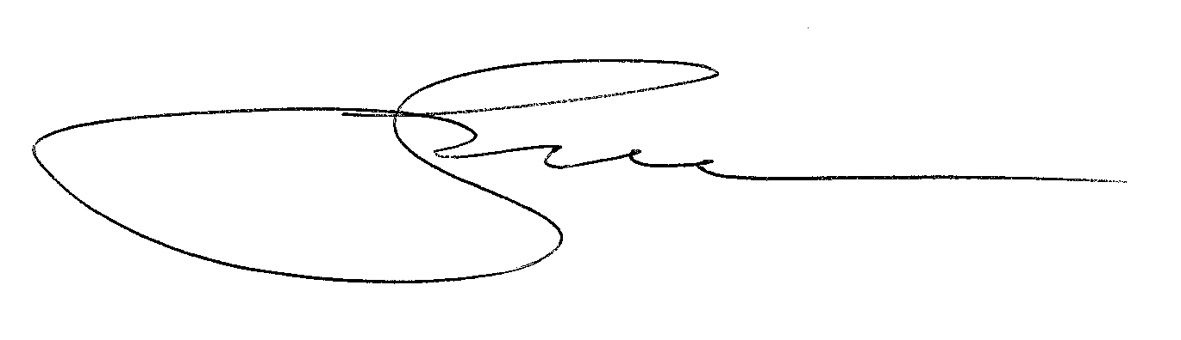

cc: KLC Chairman Sommer
/tmp/in/input.doc

